File Storage

Definition
# Source: AI Source: Provided by: [Data Path: Persons Table -> ID Column: 1, Name_En Column: Motasem Essam] -> From: [Chatgpt (GPT‑5 Mini)] on [12/10/2025]
File storage is a method of storing data in files on storage media such as hard drives, SSDs, or cloud folders.
- Data is organized in individual files rather than tables.
- Files can be documents, spreadsheets, text files, images, or CSV files.

Key idea:
# Source: AI Source: Provided by: [Data Path: Persons Table -> ID Column: 1, Name_En Column: Motasem Essam] -> From: [Chatgpt (GPT‑5 Mini)] on [12/10/2025]
File storage is like a digital folder system, where each file contains data that can be opened, read, or modified.

Characteristics of File Storage
# Source: AI Source: Provided by: [Data Path: Persons Table -> ID Column: 1, Name_En Column: Motasem Essam] -> From: [Chatgpt (GPT‑5 Mini)] on [12/10/2025]
- Simple and easy to use – ideal for small datasets or documents
- Organized in folders – files can be grouped by project, type, or date
- Less structured than databases – searching large amounts of data is slower
- Good for documents and media – supports various file formats (text, CSV, images)
- Accessible locally or via cloud – can be stored on a device or online

Example
# Source: AI Source: Provided by: [Data Path: Persons Table -> ID Column: 1, Name_En Column: Motasem Essam] -> From: [Chatgpt (GPT‑5 Mini)] on [12/10/2025]
A company keeps product inventory in a CSV file:
Inventory.csv
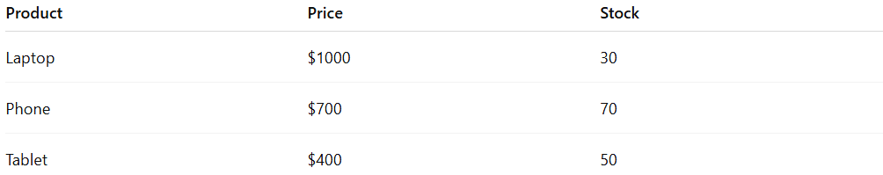
Product | Price | Stock
Laptop | $1000 | 30
Phone | $700 | 70
Tablet | $400 | 50
- To find all laptops, the user opens the file and searches or filters the rows.
- Unlike a database, there is no built-in indexing, so large files may take longer to search.

Advantages
# Source: AI Source: Provided by: [Data Path: Persons Table -> ID Column: 1, Name_En Column: Motasem Essam] -> From: [Chatgpt (GPT‑5 Mini)] on [12/10/2025]
- Easy to create and manage for small datasets
- Can store different types of files (text, images, audio)
- Can be shared or backed up easily
- No special software needed – just a file system

Disadvantages
# Source: AI Source: Provided by: [Data Path: Persons Table -> ID Column: 1, Name_En Column: Motasem Essam] -> From: [Chatgpt (GPT‑5 Mini)] on [12/10/2025]
- Not efficient for large datasets – searching and sorting can be slow
- Limited support for data relationships – no built-in joins or foreign keys
- Data redundancy and inconsistency can occur if multiple copies exist
- Harder to maintain data integrity and enforce security
- Lack of advanced querying and indexing features compared to databases

Example Section
# Source: AI Source: Provided by: [Data Path: Persons Table -> ID Column: 1, Name_En Column: Motasem Essam] -> From: [Chatgpt (GPT‑5 Mini)] on [12/10/2025]
A shop keeps a CSV file of all sales for the month:

Date | Product | Units Sold | Revenue
2026-03-01 | Laptop | 5 | $5000
2026-03-01 | Phone | 10 | $7000
Because the data is stored in a file that can be opened and read later, this is file storage.

